(Approx. 1,678 words)

Helium Backup, a review
By Frank Ramsey, Editor, ACPCUG, Akron Canton PC Users Group, Ohio
www.acpcug.org
aframsey (at) yahoo.com

The Helium of this review is a backup program for Android phones and tablets.
It's available in the Google Play store, both free and paid editions.

Before continuing we must digress and discuss what does backup mean and what is included in a backup?

An android device can have multiple objects to backup. Phone history, phone contacts, SMS messages, system settings, customizations (Wi-Fi networks, etc.), applications and application data.

There are at least two types of applications: system, those that are installed on the device when it's purchased and those installed after the device is first turned on. Complicating the process is each application has application data (high scores for games, user ID and passwords for banking, etc.) that should be backed up for a restore to be complete.

Now some will remind me that when you first sign onto the Android device with your Google account you are offered the choice to backup and/or restore the device to the Google account. Yes, you can have the device backed up to your Google account. And Google does a great job of restoring settings like contacts and Wi-Fi networks.

If you've never used the device before Google can also install all non-system, non-private applications from every device that is backed up to the Google clouds. Unlike iTunes, you are not asked to select a backup to use. You get all the apps, no application data associated with each. Assuming you don't want every app you've ever purchased on the new device, Google backup is not a great option at least for new devices. All this points to the need for a 3rd party backup utility; perhaps two or more depending on the capabilities of the backup utility.

The first question you have to answer when you decide to backup a device “is to be backed up "rooted"? Rooting is the term used to indicate any privilege restrictions imposed by Google or the device manufacturer has been removed. It’s basically running with administrator privilege on Windows devices. Unless the device is rooted, you are running as a user with no way of performing privileged tasks such as backing up application data.

Rooting is not for everyone. Root exploits areas not available for every device. You can brick (make the device unusable) a device. There are very few reasons to root your device, other than to say you've rooted it and watch the puzzled looks on the faces of those who don’t know what this means. Basically DON'T ROOT your device.

Having said this, one exploit that rooting brings is the ability to backup application data. There are many backup tools that backup application data when the device is rooted, including My Backup, Titanium and others. Most cost $5 or so. Some provide free editions. However if you've taken the risk to root the device spend the money and pay for a quality backup tool for it!

For non-rooted devices, there are many free and paid highly-rated backup tools. There is only one backup tool for non-rooted devices that also backs up application data. Helium. Period.
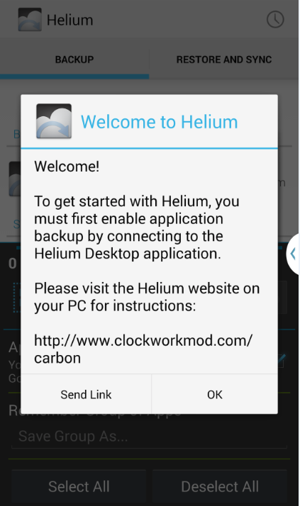
Now that we’ve covered backups and the types, let’s look at Helium.

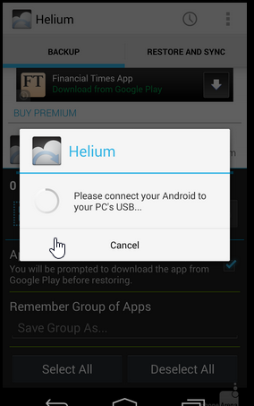
Helium is from ClockworkMod. It’s unique in that there is a desktop component also required, at least to start the backup process. This is how the developers get around the non-root device application data backup dilemma.

To install Helium, search for it in Google Play and install it. Then Open it. You’ll get the screen as shown at the right. Click OK.
.
You are requested to connect your Android to your PC or MAC.

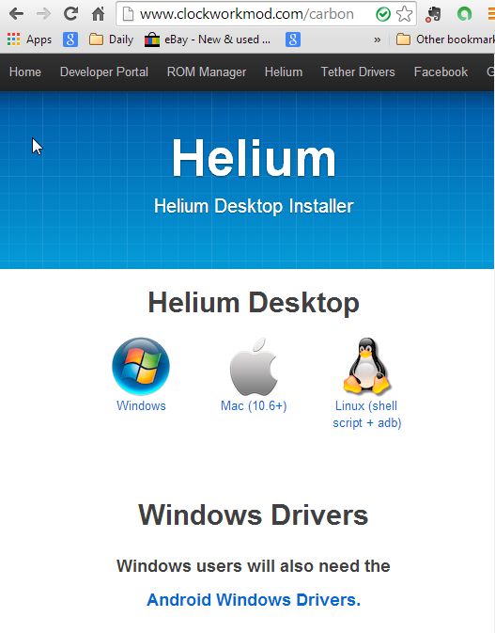
Fire up your PC or MAC and go to the link shown at the right for the desktop application and drivers.

Download the appropriate Helium Desktop and install it.

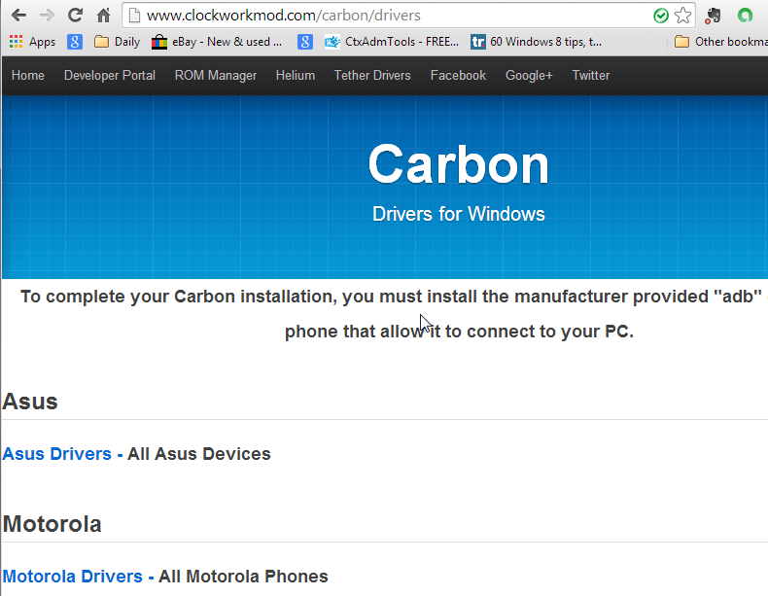
If you are running Windows, click on the Android Windows Drivers and scroll through to select the manufacturer of your device. Download the drivers and either install (if the download is an .exe) or open (if the download is a .zip) and follow the instructions in the .zip file to complete the installs.

Plug in a USB cable into your phone and and plug in the USB cable to the PC/MAC and the phone. The phone should be recognized.

Once the required drivers are installed, Helium will ask you to enable USB debugging on the device. Press OK to go to developer Options and select USB debugging. If you are warned, click OK to continue.

Now Helium will say mount the device in Photo sharing mode and takes you to the location to select this.

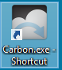
Finally, you are ready to run the Helium desktop. Click on the Carbon shortcut on the desktop.

Yes, I know, the desktop portion of the tool is called Carbon and the Android part Helium. In fact, the backups made by Helium are stored in a folder called Carbon on the Android device. Once you launched, the Carbon shortcut title of the application is Helium.
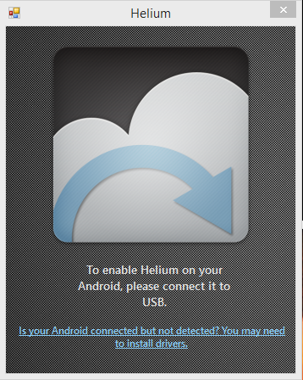
Once you’ve started Carbon, you get the Helium desktop
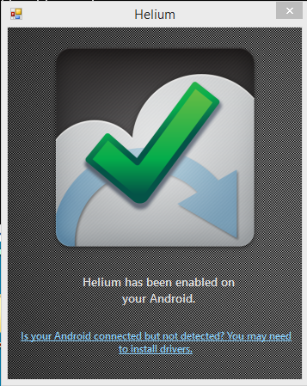
If your device is connected by USB and the device is running Helium, once the connection is made, the desktop will show the success Check.

During the connection process, the device will show a connection message. Click “Always allow this computer” and then OK. If you’d rather be prompted every time, don’t click the “Always …”; just click OK.
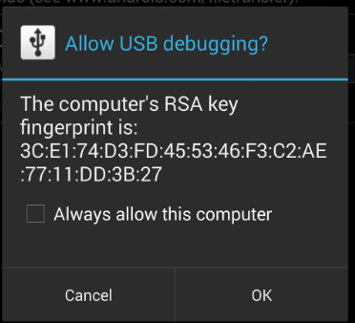
You can now disconnect the Android device from the PC/MAC. You have successfully enabled all Helium features on the Android device. Typically, you must go through activation process the first time Helium is started on the Android device following boot.

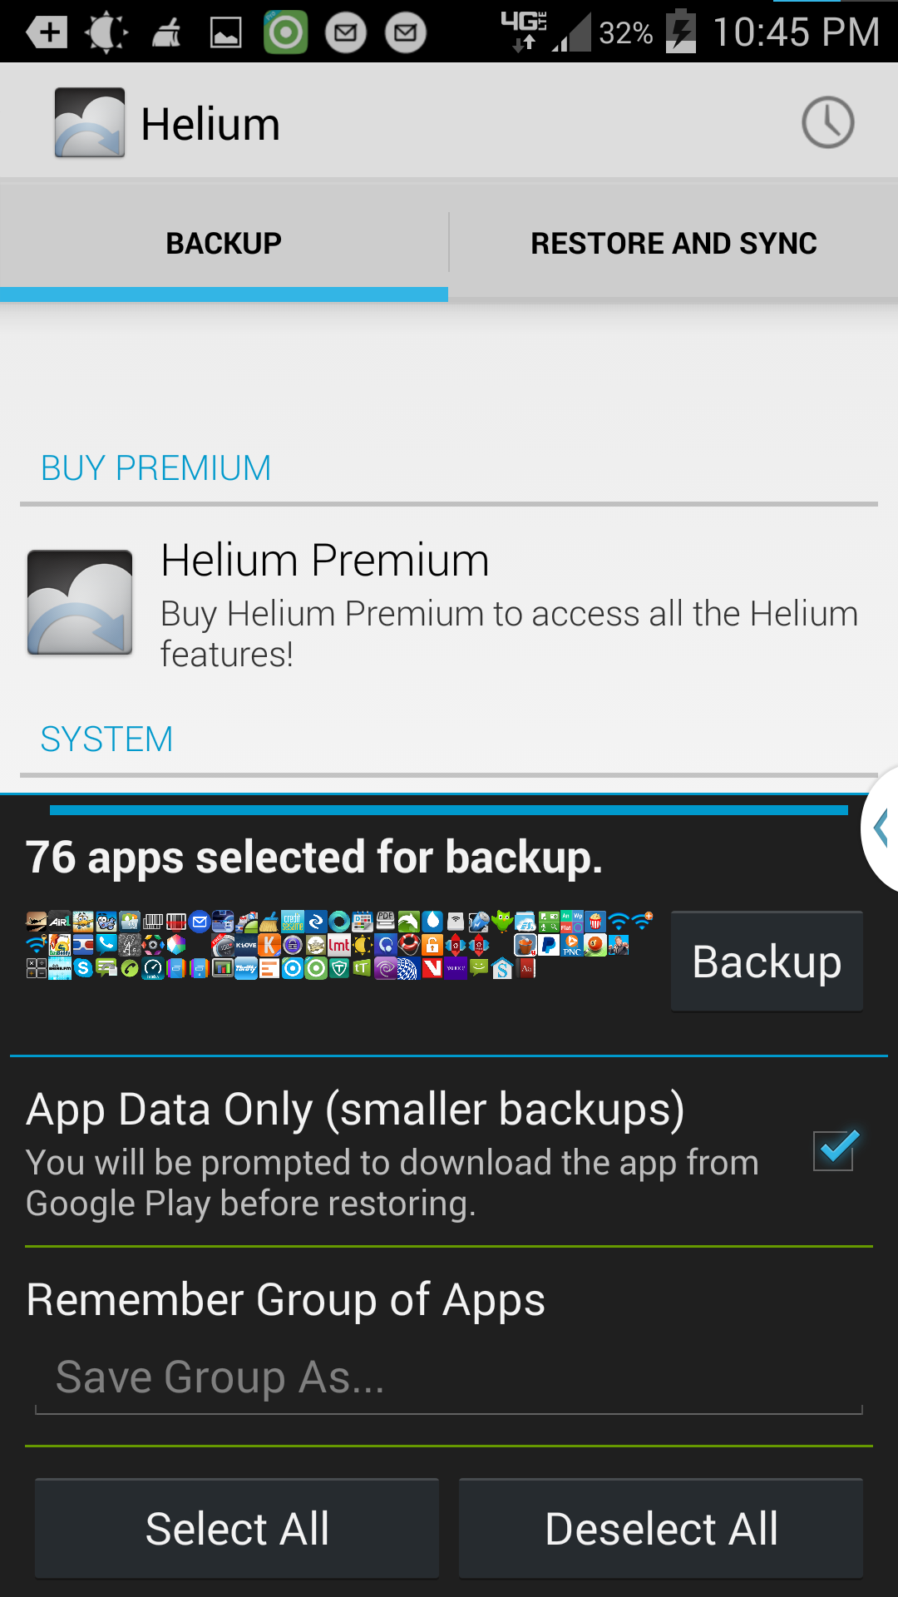
From now on, we will be referring to Helium on the Android device.

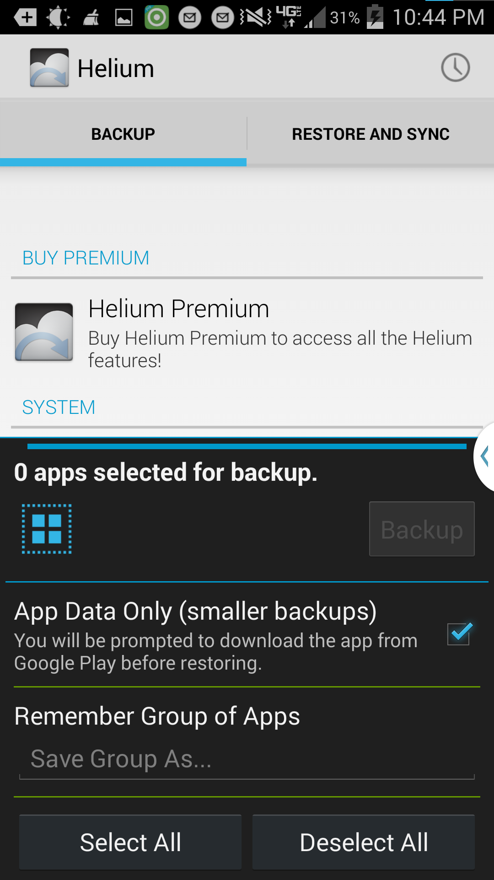
Notice the activated Helium screen shows 0 apps selected and the App Data Only box is checked.

To select all applications to backup, press the Select All dialog box. Icons for the apps to be backed up will be displayed and the apps will be counted.

To select individual applications, swipe up in the Helium Premium window. A list of applications and system settings to backup is displayed.
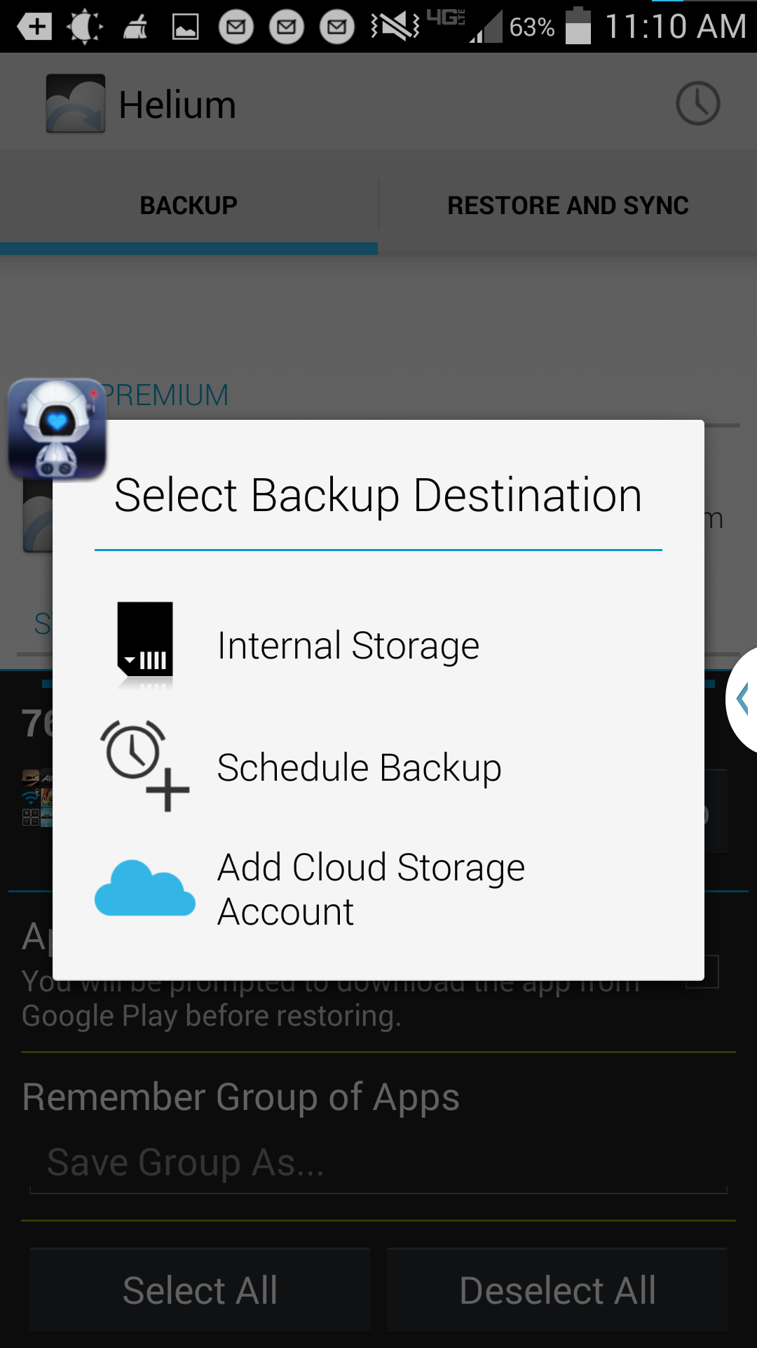
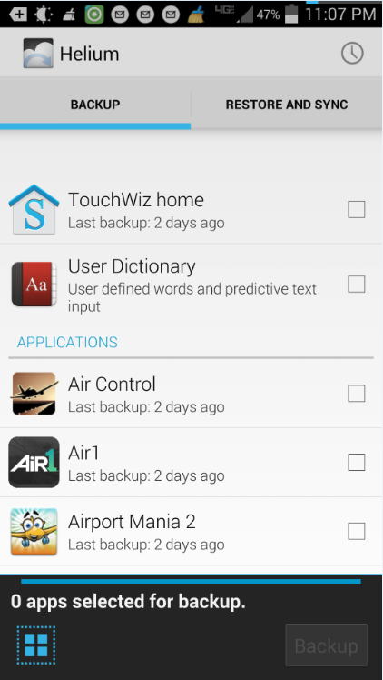
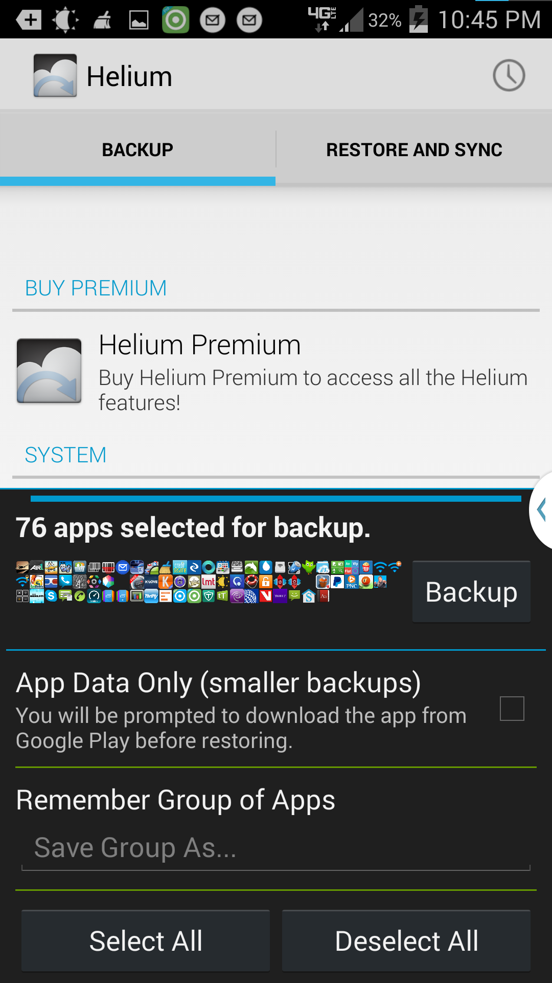

You are ready to continue. NOTE: if the App Data Only box is checked, you will backup ONLY the application data for each application and not the actual applications. While this does make for smaller and faster backups, restoring is a pain as you must first get the app installed before you can restore the apps application data. Read my article on restoring my phone from scratch and make your own decision.

To start the Backup, click the Backup button next to the Icons for the applications.

Select where to put the backup. I’ve only used the Internal Storage option and not tried the Add Cloud or Schedule Backup.

You will be given the chance to encrypt the backup by specifying a password. I suggest NOT using a password. The dialog is displayed very quickly, so if you want to specify a password, make it quick!

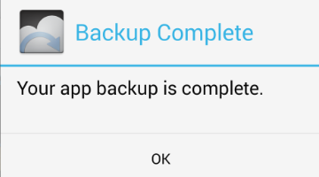
Once you select the location, the backup starts. Various dialogs are displayed showing the app currently being backed up and the backup progress. Eventually you get a successful backup message. Click OK to return to the Helium main screen.

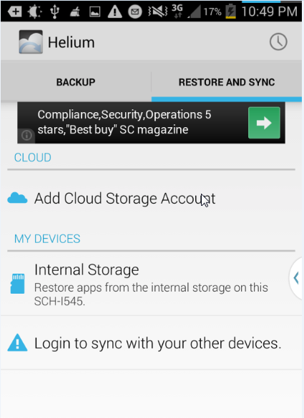
Now that you have the backup, your device is protected.

To restore from Helium, open the Helium desktop, activate it with the desktop if prompted, then click on the RESTORE and SYNC tab. Select the location of the backup. The backups available are displayed.

The list of applications backed up shows the Not Installed apps first, then the installed ones.

Select the app for restore and click the restore button.

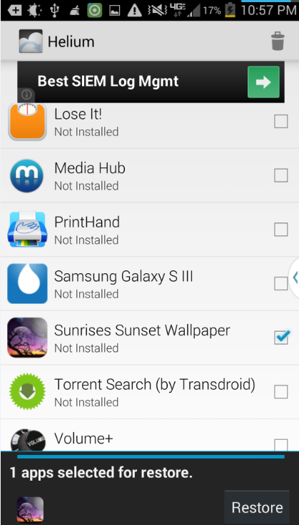
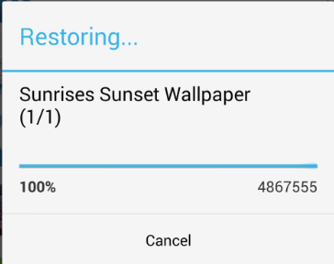
After the restore completes, you will get a restore success message.

If you selected multiple apps to restore, you may get various dialogs asking you to confirm the installation of each app. Follow the install of each app, press the Done button, if prompted. DO NOT press the Open button as restores will stop.

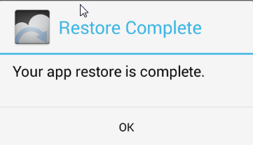
Reboot the device to active the new applications and data. And enjoy.

That’s the story of Helium, an Android backup and restore tool that can backup application data without requiring “rooting” of the device.

You may wonder how to protect the backup you just made, especially if the backup is on the Android device of interest.There are a couple of ways. One is to store the backup in the Cloud, Dropbox, or other backup destinations.
Another is to copy the resulting backup to another device. If the backup is stored in the storage of the Android device, the storage location is a folder called Carbon. All that’s required is copying the Carbon folder to another location, either using an OTG (On-the-Go) cable and USB flash drive or connecting the device to a PC/MAC and dragging the folder from the device to the PC/MAC.

If you are using Helium to switch devices, back up the old device. Copy the Carbon folder to external storage. Turn off the old device. I suggest actually wiping the old device after you’ve verified all the stuff you want has been successfully moved.

Install Helium and activate it with the desktop on the new device. Copy the Carbon folder from external storage to the new device. Then use the Restore tab in Helium to restore your applications and application data.

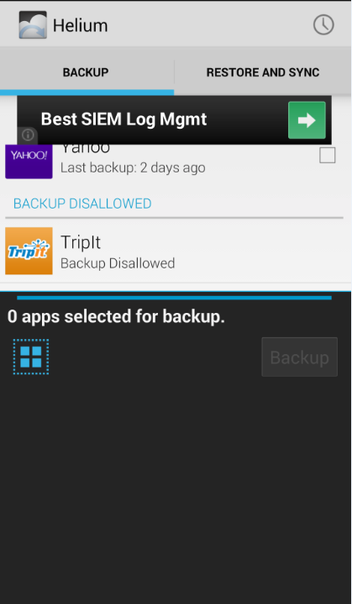
A final note. There are a few applications that do not allow Helium to backup application data. You can find these by scrolling down in the backup window to the BACKUP DISALLOWED group.

For these applications, Helium will backup and restore the application but cannot backup or restore the application data. This is the choice of the application developer, not a problem with Helium.

Typically, applications that do not allow application data backup store their information in the Cloud and require you to login by a userid and password. Therefore the application data is stored in the Cloud and retrieved by the application when you authenticate it.

